Docker and Kubernetes Hands-on Session

**WolfPack Documentation Repository** - Installation, Presentation, Labs: <http://bit.ly/WolfpackDockerK8s_Session>

The labs associated with the Docker and Kubernetes session requires that each of these technologies be installed prior to participating in the lab. Docker has outstanding installation documentation that make its installation easy, the same holds true for Kubernetes. If you already have Docker installed, please ensure that it is at least Docker version 17.06.

\*\* Please note that you need to have administrator privileges on your laptop to install these technologies and make the necessary changes to your laptop. Also, your operating system must be 64-bit, not 32-bit.

**Installing on Windows 10 (Pro or Enterprise)**

This is the best experience on Windows, but due to OS feature requirements, it only works on the Pro and Enterprise editions of Windows 10 (with latest update rollups). You need to install ["Docker for Windows" from the Docker Store](https://www.docker.com/docker-windows).

With this Edition we recommend using PowerShell with elevated privileges (run as Administrator). However, you can also use the Windows Command prompt, but it too requires elevated privileges.

Please see “[Start a Command Prompt as an Administrator](https://docs.microsoft.com/en-us/previous-versions/windows/it-pro/windows-server-2008-R2-and-2008/cc947813(v=ws.10)).”

During the installation of Docker (Windows 10 Pro, Ent) you may be prompted with:

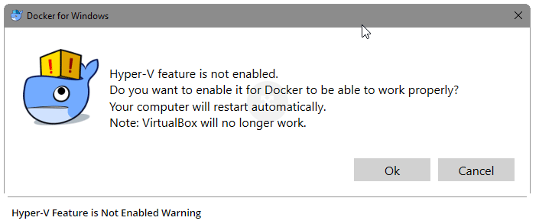

Hyper-V is required for Docker to run on this platform. \*\* Please note, if you are running VirtualBox it will no longer work once you enable Hyper-V.

**Installing on Windows 7, 8, or 10 Home Edition**

Microsoft's OS features for Docker and Hyper-V doesn’t work in these older versions, and "Windows 10 Home" edition doesn't have Hyper-V, so you'll need to [install the Docker Toolbox](https://docs.docker.com/toolbox/overview/), which is a slightly different approach to using Docker with a VirtualBox VM. This means Docker will be running in a Virtual Machine that sits behind the IP of your OS and uses NAT to access the internet.

**NOTE**: For all examples that use http://localhost, you'll need to replace with http://192.168.99.100

VirtualBox is a hypervisor which requires your computer to be configured to support virtualization (VT-x). This configuration happens in your computer’s bios. But first check to see if your system is already configured for virtualization:

**Windows 8:**

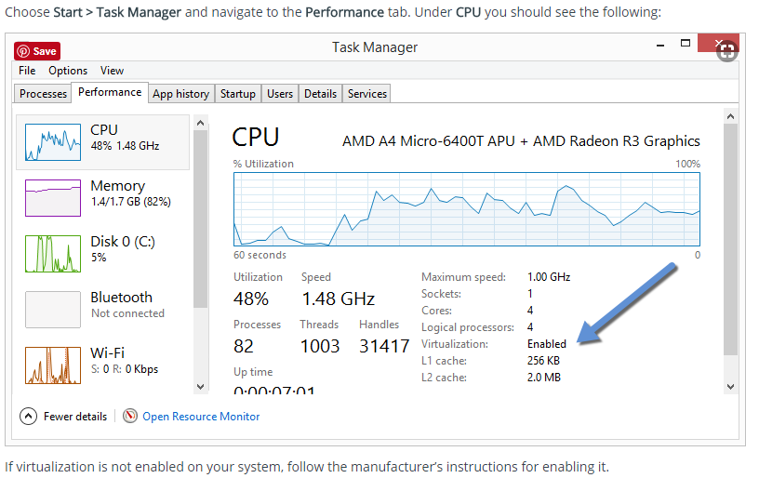

**Windows 7:**

Run a tool like the [Microsoft® Hardware-Assisted Virtualization Detection Tool](http://www.microsoft.com/en-us/download/details.aspx?id=592) or [Speccy](https://www.piriform.com/speccy" \t "_blank), and follow the on-screen instructions.

If your system in not configured for virtualization then please see: “[Enable Virtualization in Bios.”](https://helpdeskgeek.com/how-to/enable-virtualization-in-the-bios/)

**Installing on Mac**

You'll want to install [Docker for Mac](https://www.docker.com/docker-mac), which is great. If you're on an older Mac with less than OSX Yosemite 10.10.3, you'll need to [install the Docker Toolbox instead](https://docs.docker.com/toolbox/overview/).

**Installing kubectl**

You can install kubectl, the primary application for interfacing with a Kubernetes cluster, from this [link](https://kubernetes.io/docs/tasks/tools/install-kubectl/#install-kubectl-binary-via-curl). Install options are available for Windows, OSX, and Linux. Once installed, please ensure that the command “kubectl” is in your command line path.

\*\* Please note that for **Windows** installations that kubectl is just an executable “kubectl.exe.” As such you need update the %PATH% variable to include the path to this \*.exe.

**Installing minikube**

You can install minikube, which provides a locally installed 1 node Kubernetes cluster, from this [link](https://github.com/kubernetes/minikube/releases). Install options are available for Windows, OSX, and Linux. Once installed, please ensure that the command “minikube” is in your command line path.

\*\* Please note that Minikube has two installation options for Windows: Installer and stand-alone minikube.exe. In either installation you will need to update the %PATH% variable to include the path to this \*.exe.